Exploring Erosion Processes

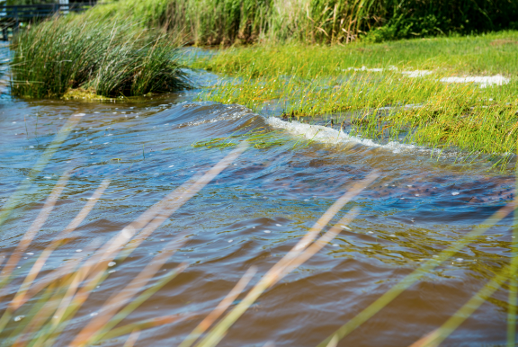
Wind driven waves lapping an estuarine shoreline.

ABSTRACT
North Carolina has over 12,000 miles of estuarine shoreline. Estuaries provide a number of ecosystem services of value to humans. Vegetation found within the estuaries provide protection against storm surge and increased wave action, in addition to being home to numerous species of invertebrates, birds, frogs, turtles, and commercially significant fish and crab populations. This program investigates the role vegetation plays in mitigating the effects of storm surge and wave action, as well as providing a sanctuary to a host of organisms. Through field activities and classroom experimentation students will explore sediment erosion due to wind driven wave energy and document the different shorelines found in coastal North Carolina.
Grade Level: 6-12

Duration: 90 minutes

Standards: PS.6.3.1, LS.6.2.2, ESS.6.3.2, ESS.8.2.1, ESS.EES.2.4, ESS.EES.3.2, ESS.EES.4.1, ESS.EES.5.1, ESS.EES.5.6, ESS.ESS.6.3

Key Words: estuary, erosion, shoreline change

MATERIALS
- Paint tray (1 per 2 students, 4 for demonstration)  - 12”x1” piece of Astro-turf (1 per students, 1 for demonstration)  - Sand (1 container per team)  - Soil (1 container per team) | - Gravel (1 container per team)  - Water  - Measuring cup (1 per team)  - Wave paddle (i.e. plastic container lid)  - Ruler  - Stopwatch
BACKGROUND

For class: CSI Estuaries videos
https://youtu.be/SUxEiMVL_AQ?si=byKNh3z8HPjQulwX
https://youtu.be/h01JBiZt6rg?si=JMZ4IdQYl9fdEixT

For teacher: CSI Science of the Sound Lecture https://youtu.be/p5tvOYG5hy8?si=cYqLYbnCKdiGBi8I

FRAMEWORK

Introduction: 15-minute presentation and video on shoreline types and erosion Exploring Shorelines on the grounds of CSI: 15 minutes Shoreline creation experiments: 15 min Shoreline development competition: 45 min.

Slide 1: Introduction – Welcome to UNC CSI. We are a research and education institution that is part of the UNC system.

Slide 2: Today we will be talking about the different estuary types, the ecological services that estuaries provide, and identifying estuarine shoreline types. We will then head across the grounds to the Marine Operations Building (MOB). On our way we will look at and discuss the different shorelines right here at the facility. At the MOB we will see how shorelines stand up to wave action and discuss observations about the different shorelines. Lastly, you will be given a chance to construct your own shoreline and see how it stands up to erosion.

Slide 3: The coast of North Carolina has 325 miles of ocean shoreline. These are the beaches that make the Outer Banks famous, but they not the only shoreline on the coast. This is nearly 40x more estuarine shoreline than ocean, covering an area of 12,000 miles. Scientists from UNC CSI partnered with a state agency to map the intricate shoreline of our estuaries. You will see a video about this process in a few minutes.

Slide 4: It is important to note that there are three types of estuaries in North Carolina and that each type is unique in the habitats they provide and the ecological diversity of their make-up. Some of the organisms found in these estuaries begin life in one type as a juvenile and move to another as they mature, and some eventually move out into the open ocean. Fish like shad and sturgeon are anadromous fish, which reproduce in rivers but live their lives in the ocean. Most eels spend their lives in fresh or brackish waters but go to sea to spawn. That makes them catadromous. The three types of estuaries found in North Carolina are the tributary, trunk, and back barrier sound. If we look right outside this building, what type of estuary can we see?

Slide 5: The estuaries in North Carolina provide important ecological services that are important to us. What is an ecological service? What fisheries do we rely on here in North Carolina?

Slide 6: The nitrogen cycle and the role of SAV and marshes have in removing nitrogen while producing oxygen.

The Nitrogen Cycle
In natural environments, nitrogen is frequently stored as decaying organic materials. It also is constantly being removed and added to both the biotic and abiotic environment in a complex biogeochemical cycle. "Fixed" nitrogen enters the biotic environment through the decay of organic materials (releasing amino acids, etc.), weathering, or from fixation by specialized bacteria. Generally, nitrogen is in the form of ammonium (NH4+) at this point and must undergo further modification to be more readily usable by plants. The process by which ammonia is converted to nitrites and nitrates is called nitrification. Two groups of microorganisms, Nitrosomas and Nitrobacter, drive this part of the nitrogen cycle. First, Nitrosomasbacteria utilize the ammonia available in soils as a source of energy. They metabolize the ammonia and promote its oxidation to nitrite ions and water. The nitrite-rich metabolic waste of these bacteria is then available as a food source for Nitrobacter bacteria, which oxidize the nitrite ions to nitrate. Plants then utilize nitrates for growth and respiration. Nitrogen taken up by plants is released as amino acids when the plant's tissue is eaten or the plant dies and begins to decay.

Slide 7:
De-nitrification
Nitrogen is also lost from the biotic portion of the cycle in two ways—denitrification and mineralization of organic materials. Mineralization of decaying organic matter binds the nitrogen in the abiotic environment until weathering releases it. De-nitrification, or the reduction of nitrate to atmospheric nitrogen, is catalyzed under special, anaerobic conditions by denitrifying bacteria, such as Pseudomonas.

Slide 8: Coastal Processes
The barrier islands were formed and persist at the interface between the land, sea, and air in response to four physical factors:
1) The presence of the gently sloping Coastal Plane – Continental Shelf
2) The availability of adequate sediment
3) A rising sea-level4) The occurrence of high-energy oceanic storms
They act as a buffer or dam between estuaries and ocean. Coastal processes such as wind, wave, and current are constantly reshaping these barrier islands.
Wind – produces waves and currents within the sounds
Waves – batter shorelines and kick up sediment
Currents – carry suspended sediment

Slide 9: Natural Estuary Shorelines
Discuss and describe each and the advantages/disadvantages

Slide 10: Modified Shorelines
Discuss and describe each and the advantages/disadvantages

Slide 11: Erosion in Our Estuaries
What does erosion look like?
What does it mean?
What causes it?
What can be done?

Slide 12: Video on shoreline mapping

