Ocean Energy and Education

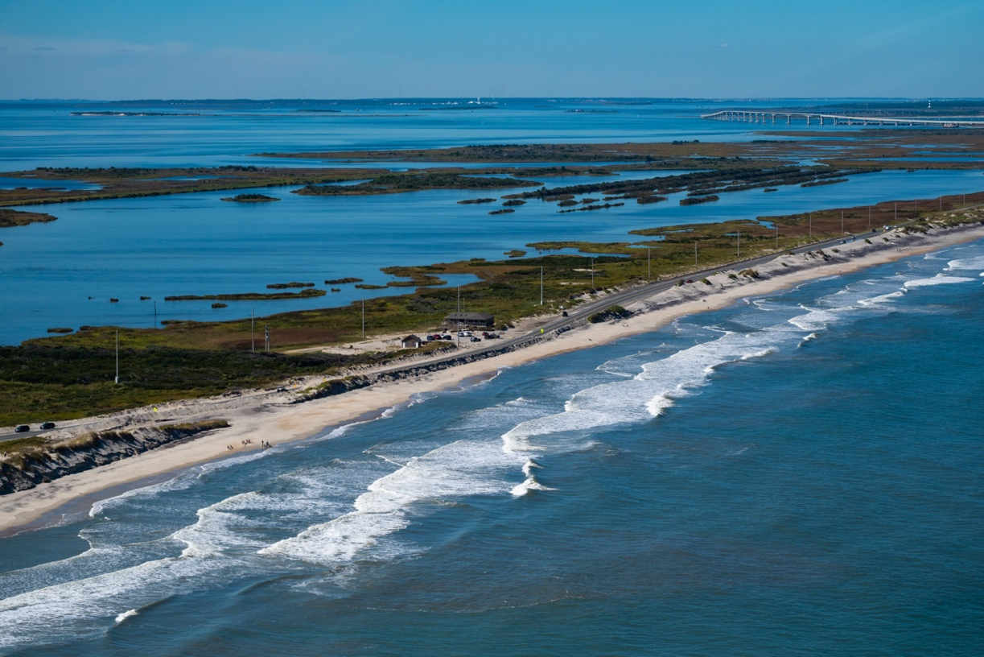
Waves are a potential energy source for the future.

ABSTRACT

Grade Level: 7-12

Duration: 90-120 minutes

Standards: PS.PSc.6.4, PS.PSc.7.2, PS.PSc.8.1, ESS.8.4, ESS.EES.5.4, ESS.EES.5.5PS.Phy.5.2, PS.Phy.6, PS.Phy.7.1

Key Words: alternative energy, waves, ocean currents, electricity
As the population of this planet continues to increase, and the availability of nonrenewable sources like fossil fuels remains limited, there is a need to identify and develop new sources for our electrical energy needs. One source of renewable energy that has the potential to be harnessed in North Carolina is converting energy from the natural motion of water through ocean currents and ocean waves into electricity.
Based at the Coastal Studies Institute (CSI), the North Carolina Renewable Energy Program (NCROEP) currently leads an effort to assess the feasibility of this type of energy for North Carolina. The NCROEP is focused on identifying the resource that is available offshore, engineering new technology for energy storage and transfer, and understanding the impacts that energy creation could have on surrounding environments. This program will introduce the subject of ocean energy and outline the types of technology used to harness energy from the ocean. Students will explore the basics of electricity by building a basic generator.

OBJECTIVE
Inspire students to think about the energy challenges we face and the role of alternative energy sources in future power production.
MATERIALS
Presentation  - PowerPoint  - Internet for videos  - Projector | Shake-a-generators  - 35mm film canister  - Insulated copper wire (30-gauge magnet wire)  - Magnets (neodymium magnets work best)  - Sandpaper  - Scissors  - Tape  - Voltmeter

BACKGROUND
Cape Hatteras juts out into the Atlantic Ocean in a place where currents converge, creating a very dynamic and powerful environment. It has been the goal of the Coastal Studies Institute to lead a program in partnership with schools of engineering at UNC Charlotte, NC State, and NC A&T University to investigate the power potential available off the coast of North Carolina. The mission of the North Carolina Renewable Ocean Energy Program is to “use renewable ocean energy wisely to effectively and economically power North Carolina’s Blue Economy and in the process create jobs and economic opportunities.” NCROEP research is focused in four areas: assessing the power available in the Gulf Stream, improving the efficiency, maintenance, and power outputs of renewable devices, assessing environmental impacts and regulatory concerns, and assessing marine hydrokinetic device testing in the field.
Assessing the power available in the Gulf Stream includes oceanographers using Acoustic Doppler Current Profilers (ADCPs) to research the movement of water in the currents. They are attempting to define the western edge of the Gulf Stream and are searching for the ideal location for placing an energy-capturing device. The Gulf Stream is a warm water current that flows at an average speed of 5 miles per hour, just 15 miles off the coast of Cape Hatteras and has more power in water movement then all the rivers in the world combined. There is immense potential as an alternative energy source if we can identify the most consistent and economical location.
Researchers have also been working on creating magnetic gearing systems, as opposed to mechanical gearing systems, that do not require gears to make contact with one another. These magnetic gears would reduce maintenance issues and last longer before wearing out. Many of the ocean current alternative energy devices may be deployed at deep depths, and servicing and maintaining them is a significant challenge. These gears will also convert the low rotational speed of renewable energy sources to a high rotational speed needed for power generation. There is also on-going research on ways to store electrical current until it is needed. Researchers are working on a compressed-air gas storage device that would take advantage of the pressure gradient. This device would store energy as compressed gas under water, which would be released from depth and run through a gas expander with a generator to produce energy on demand.
Placing any type of equipment on the seafloor requires significant permitting. The NCROEP has undertaken creating guidelines to deploying ocean energy equipment in North Carolina. The NCROEP is also interested in potential environmental impacts from using the ocean as an energy source. Research has identified species that may be impacted by harnessing energy from the ocean. Identifying human users of these areas is also important for success moving forward.
There are a number of different devices currently in use to capture ocean current and ocean wave energy in other geographic locations. The point-absorber device, pictured below, floats on the surface of the water with an anchoring system to the bottom. As surface waves push the point absorber up, it uses Faraday’s Law to create an electrical current. Another device called the Surge WEC is placed on the bottom in near shore environments. When waves pass over top of the device, the paddle moves back and forth, which can be used to pump hydraulic fluid or spin a generator. The PowerPoint uploaded with this lesson plan provides an outline of these devices, in introduction to electricity, and an overview of the NCROEP is provided in the video link. Many devices use Faraday’s Law to create electrical current from the movement of high-powered magnets through coils of copper wire.

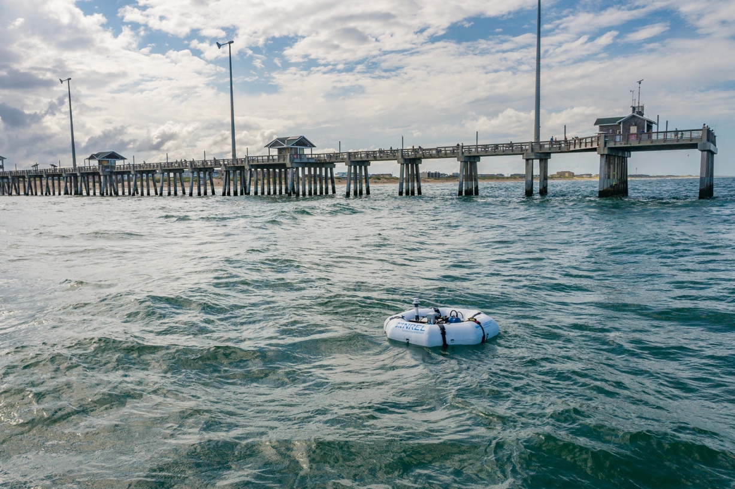
Wave energy conversion device off of Jennette’s Pier.

PROCEDURE
Engagement: Introduction to ocean energy: We live in a society that continues to rely on fossil fuels for majority of our energy needs. Alternative energies are a valuable resource for us to utilize to reduce our reliance on fossil fuels. Who has been in the ocean before? Who has been knocked over by a wave? Would you say that the ocean is powerful? There are scientists working to convert that energy available in the ocean to electrical energy.

Exploration: The PowerPoint provided outlines the benefits of alternative energies, the North Carolina Renewable Ocean Energy Program, and examples of ocean energy devices currently being tested.

Video: https://www.youtube.com/watch?v=xD-aqPkV94U, explains options for harnessing the power of the Gulf Stream lead by CSI and the NCROEP.

Elaboration: Build a Basic Shake Generator – this displays the concept of Faradays Law and is used in the technology of ocean energy devices.

1. Coil 500 – 1000 turns of copper wire around a film canister
2. Leave 6 inches of wire free on both ends (before and after wrap)
3. Strip insulation off wire ends to make a clean connection
4. Connect to very small LED light or voltmeter
5. Place a powerful magnet inside canister and close canister.
6. Shake magnet back and forth – this should create a voltage

For more detailed instructions visit:
https://www.instructables.com/Shake-A-Can-Generator/

EVALUATION
In the classroom a basic evaluation of how well each generator works would provide insight into how well they follow directions and understand the principals used to create an electrical current. Student evaluation at CSI will be done by monitoring the amount of voltage created by each of the ocean energy devices. To engineer a working ocean energy device, students will have to understand the dynamics of waves, Faraday’s Law, and some engineering principles. The discussion questions below can be used to start a discussion in class.
DISCUSSION

- Explain how the movement of water can be turned into electricity?

- Some water current turbines look a lot like wind turbines. Why do current turbines spin at slow water speeds but wind turbines need a minimum of a few miles per hour of wind to spin?

- What is Faraday’s Law?

- What are some challenges with using alternative energies?

- What are CSI and NCROEP doing to overcome these challenges?

- Do you think the Gulf Stream is a good source of energy? Why/why not?

EXTENTIONS
CSI offers a variety of K-12 programming on the ECU Outer Banks campus on Roanoke Island. The Electric Currents & Energizing Waves program provides students the opportunity to learn electricity concepts through hands-on experiences, make observations about devices and waves in a 10-meter wave tank, and engineer their own ocean energy device to compete against their classmates to create the most electricity.

Background Reading for Teachers: http://cfpub.epa.gov/ncer_abstracts/index.cfm/fuseaction/display.abstractDetail/a bstract/8093/report/F
http://www.ucsusa.org/clean_energy/our-energy-choices/renewable-energy/howhydrokinetic-energy-works.html#.VMuzZCcn1BI
http://www.epa.gov/region1/eco/energy/re_ocean.html

